**DayBreak Milestone 1**

**Problem Statement**

We are hoping to build an application for people wishing to improve their lives by reducing self-identified negative behavior, especially addiction related habits. Specifically, we hope our app is able to aid in this process without casting judgement on users. It is our belief that there is currently no person-centered approach being offered digitally and mobile for those affected by addiction. Besides just addiction we hope to reach out to those with any self-identified negative behavior they personally find troublesome and need help overcoming.

**User Research Summary**

For our user research, we created a simple google form asking a variety of questions relating to self-identified negative behavior. The data collected was from 25 different individuals, all of which were between the ages of 18 - 23, female and male and attended the University of Georgia as undergraduate students. We did not collect any personally identifiable data due to the sensitive nature of the survey.

The most important conclusion to be drawn from the user research we conducted, was that every individual reported that they had a self-identified negative behavior that they are trying to reduce. Both the type of behavior and length of time exhibiting the behavior was fairly evenly spread amongst the different categories. On average, the self-identified negative behavior impacts the individual’s daily life at a 6.16 on a scale of 1 to 10 with 1 being the least affected and 10 being the most. In addition, 84% of individuals stated that they have tried, unsuccessfully, to reduce their behavior, through a variety of different methods. Of the methods we listed, 56% of people are attempting to refocus their attention on something else to distract from participating in their behavior. Lastly, 88% of people communicated that they would be interested in an iOS/Android application that aids in helping to reduce an individual’s negative behaviors. Based on the results of our survey we can conclude that not only does the problem exist but that a large majority of people are already interested in an application to help them reduce their negative behaviors.

**User Research Results**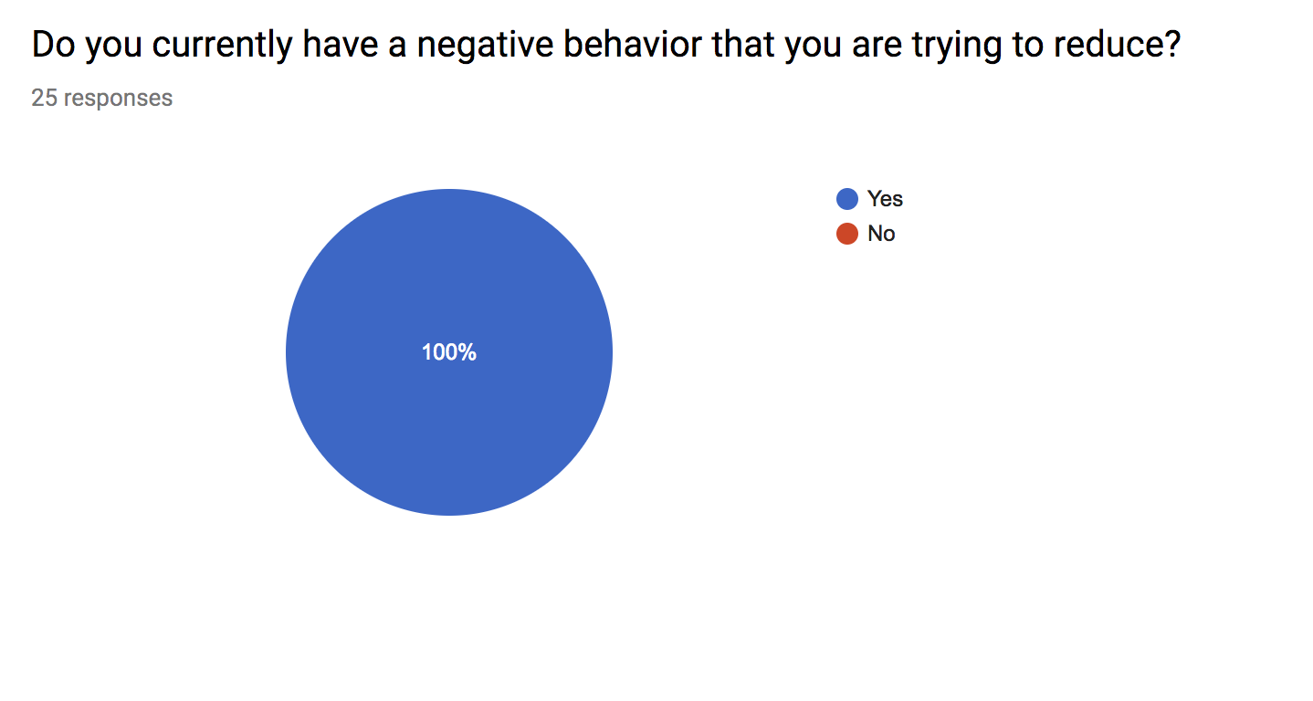

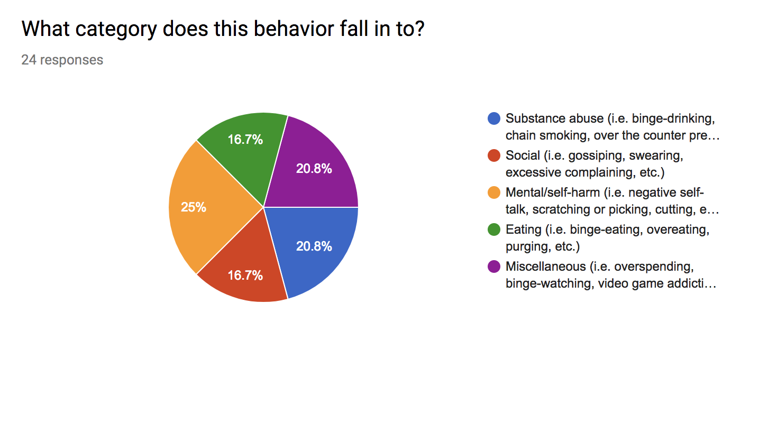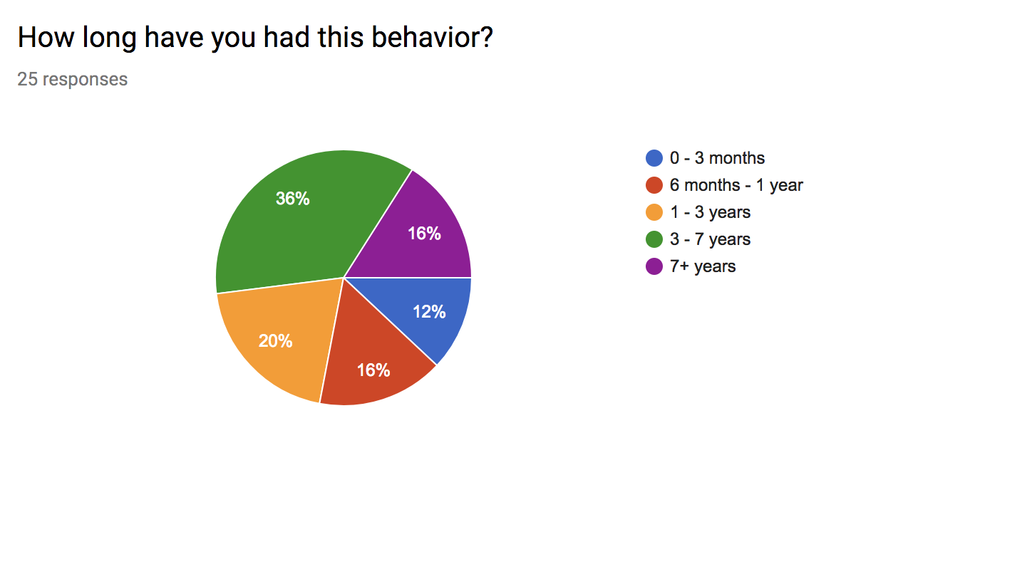

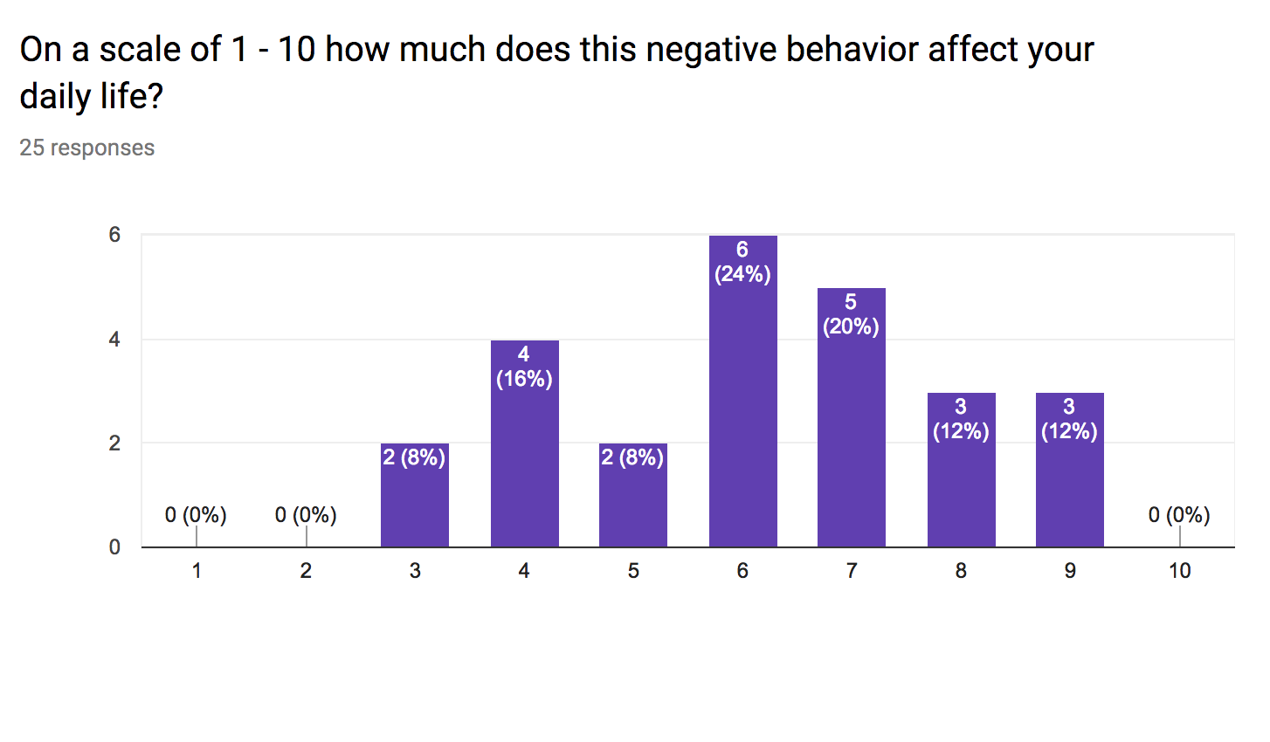

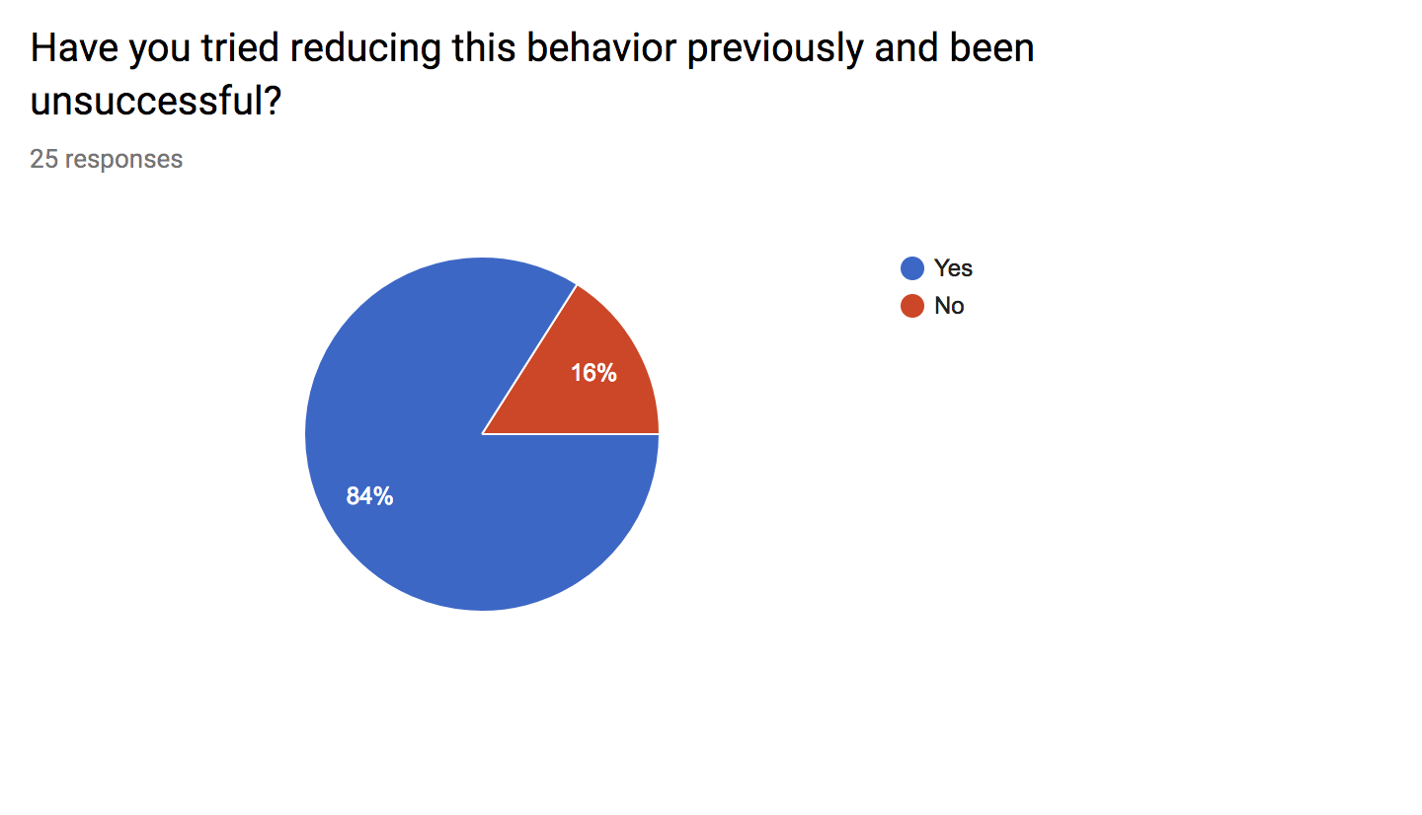

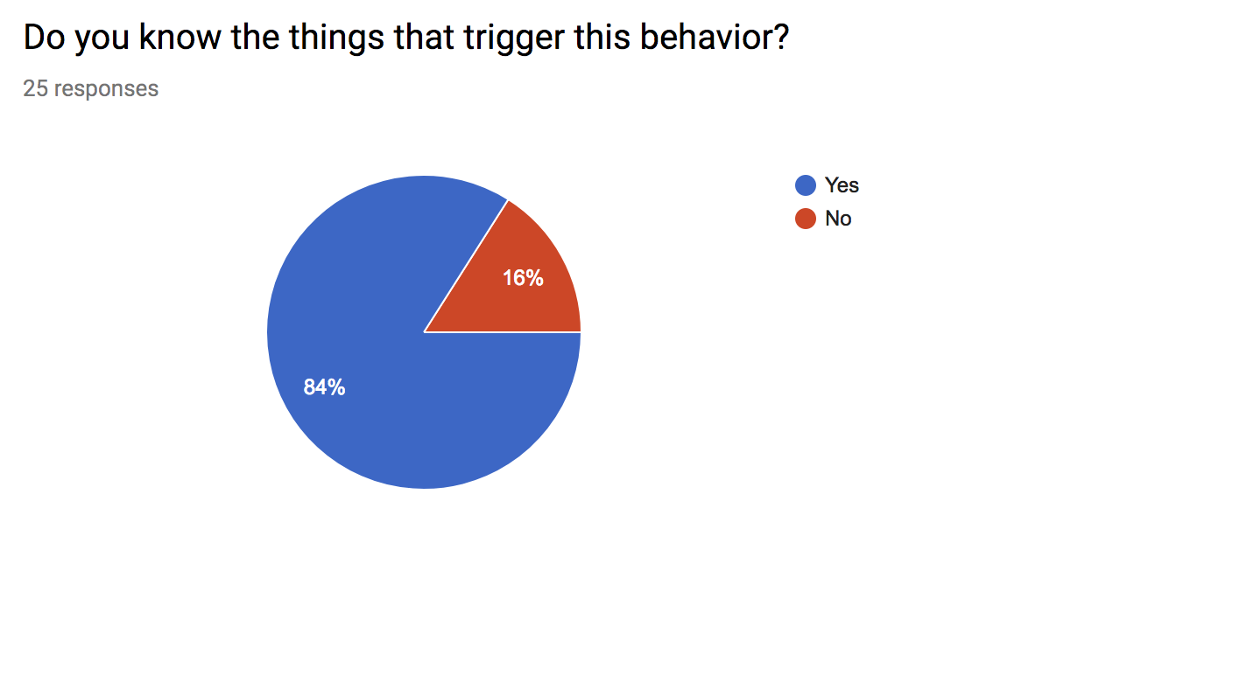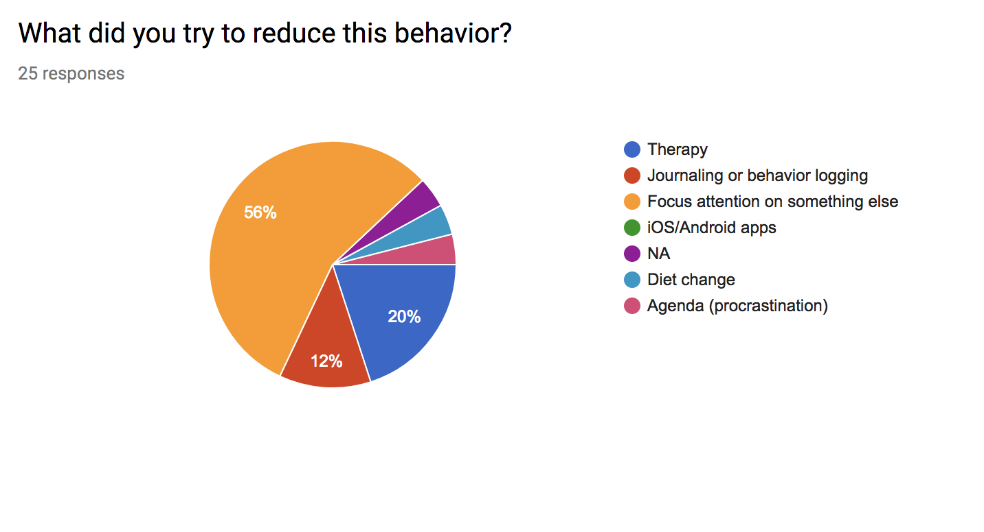

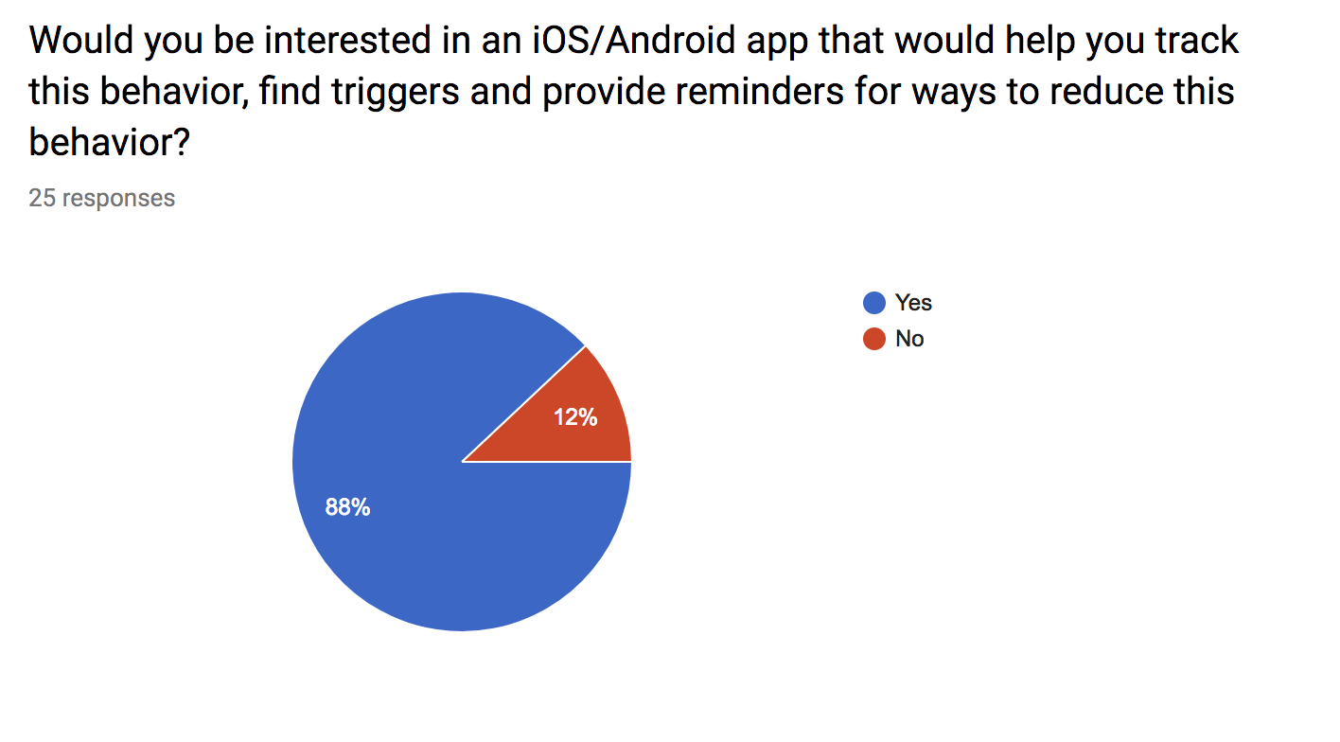

**Application Description**

Our application is a person-centered approach based off of a harm-reduction modality of treatment aimed at decreasing behavior the user has deemed problematic for themselves, with a focus on addiction. The user will approach the app with their own conceptions about what behaviors they participate in that they wish to reduce, as well as set their own goals for addressing these behaviors, as to not impose judgment on what the user is doing or what they intend to get out of their experience. With the user in charge of their own behavior, and already in possession of the will to change it, our app will prove to be an effective tool for all those whom use it as intended. We will allow the user to register their triggers, so they can be prompted to remember to avoid them as well as be prompted with productive tasks they’ve specified they would like to do. These are generally development of a skill or the creation of something (i.e. learning an instrument, making art, and reading). Additionally, we will prompt the user daily to register the strength of their cravings, as well as provide a short excerpt on how they’re feeling, for them to look back on if they should so choose. With a focus on the user’s autonomy and an approach centered on improvement rather than simply cessation of behavior, we hope to achieve a greater success than more stifling and judgmental programs.

**Task Analysis**

**Task 1: Setting up the app**

1. Downloading the app

a. Open the app store/ google play store for IOS or Android respectively

b. Search “Checking Back” on the store

c. Press the download button

2. Open the app

3. Fill in starting information

a. User fills in app prompt for behavior they would like to reduce

b. Prompt pops up for potential triggers

c. User can fill out as many of these as they want

a. Can select + to add a trigger or done to move to next step

d. Ask the user if there are any activities they would like to work on in replacement of their addiction.

4. Checking Back is now set up and will begin sending daily reminders and asking for user feedback

**Task 2: Providing daily feedback**

1. Receive notification from Checking Back

2. Open the app

3. User fills out quick set of questions

a. (not exact wording) How strong are your cravings today? (1-10 scale response)

b. (not exact wording) How are you feeling? (free response)

4. App logs user response into a calendar

5. App thanks them for providing feedback

**Task 3: Accessing previous days feedback**

1. Open the app

2. If necessary, fill out the daily feedback (Task 2)

3. Open the calendar

4. Scroll until the desired day is found

5. Click on the day to open up a page showing responses to questions on that day as well as any additional information about their activities the user provided, or the app calculated.

6. User can click back to return to the calendar or exit the app

**Existing App Research**

There already exist many mobile applications designed to aid users in harm reduction through features such as behavior logging, visualization of the behavior through charts and statistics, and by providing helpful information about decreasing the frequency of harmful behaviors. Our app differs from existing apps in that we are not targeting one particular behavior or habit. We wish to help and be applicable to users who suffer from any behavior that they wish to reduce or quit including, but not limited to smoking or nicotine consumption, excessive drinking, recreational drug use, self-harm, or excessive spending.

Everyone who progresses through a reduction of harmful behavior will do so at a different rate. Rather than giving the user predefined milestones to reach over a prespecified period of time, we believe that it is important to allow the user to define their own objectives to strive towards at whatever pace they feel is appropriate for their situation. Users of the app will be urged to write daily about their engagement in the behavior, their cravings to engage in the behavior, the things that trigger their cravings, how they are generally feeling, and any other information that they may think is important for their harm reduction. Rather than just recording usage, our app, through these daily memos, will allow the user to reflect on their behavior and feelings as they work forward. These are features that are not present in other mobile apps designed for the reduction of harmful behaviors.

Additionally, our app differs from others currently on the market in its use of trigger logging and prompts to perform an alternative action. The user will be able to specify and list the triggers that make them wish to engage in their harmful behavior. If they recognize that one of these triggers is happening or may happen in the near future, they can utilize the app and be prompted to engage in an alternate, healthier behavior such as exercising, reading, or creating art